**Junit-Basic Testing Exercises**

**Exercise 1: Setting Up Junit**

**Code:**

unittest.java

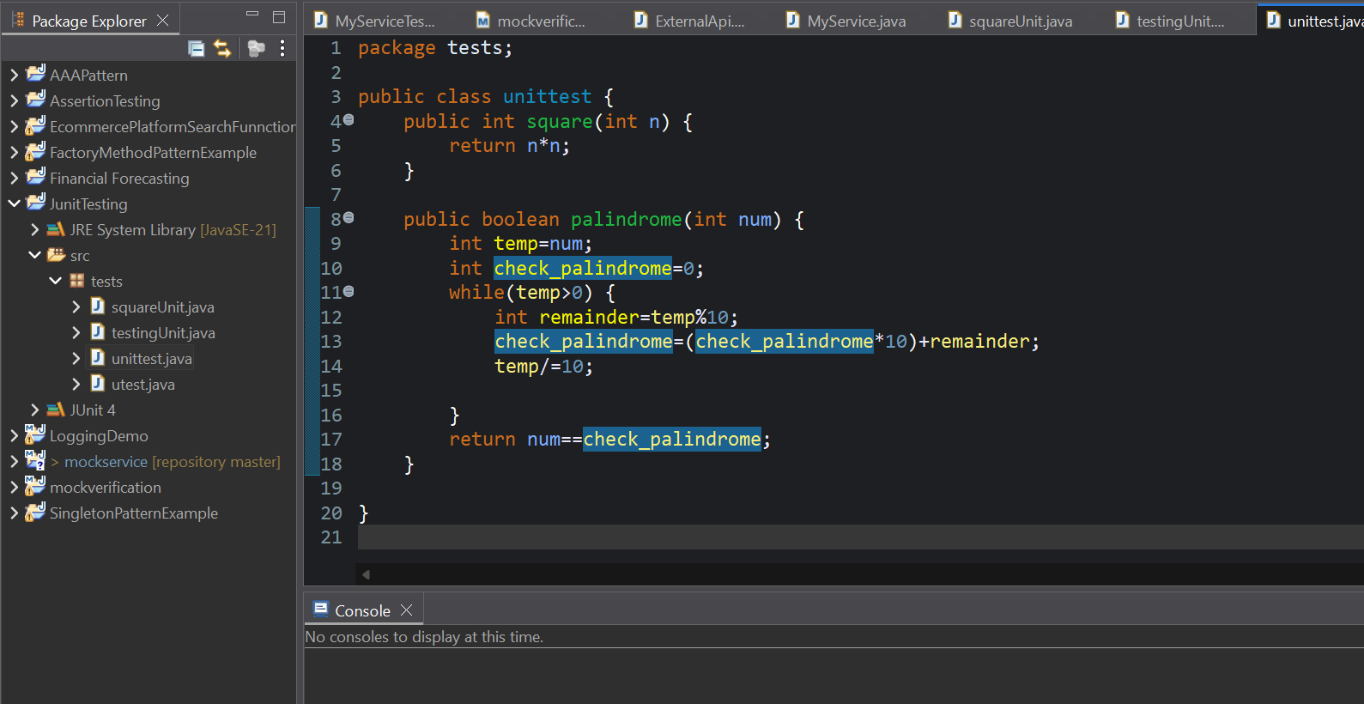

testingUnit.java

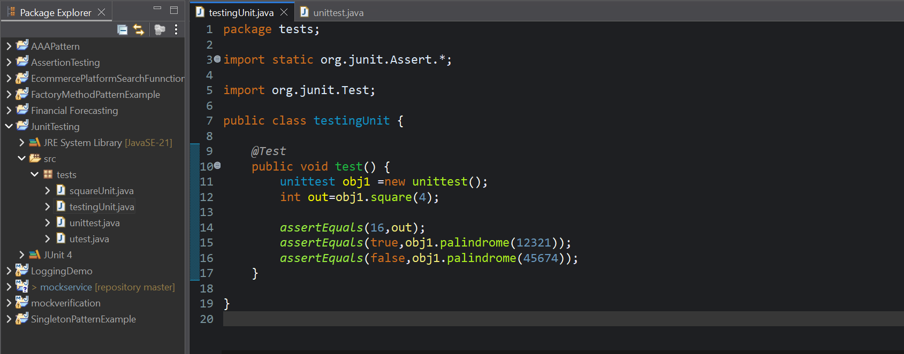

**Output:**

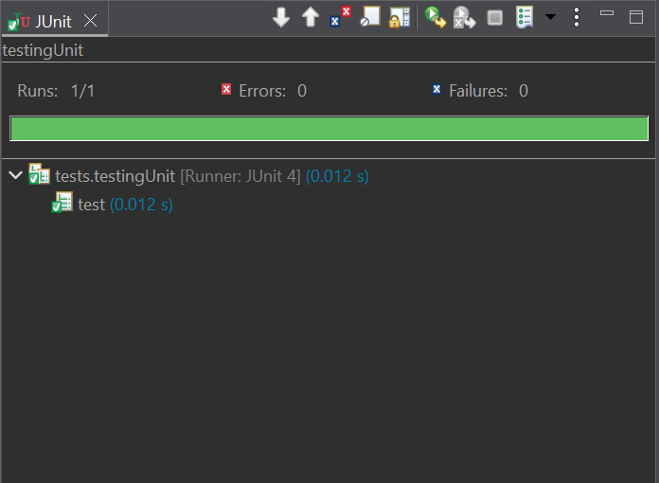

**Exercise 3: Assertions in Junit**

**Code:**

AssertionsTest.java

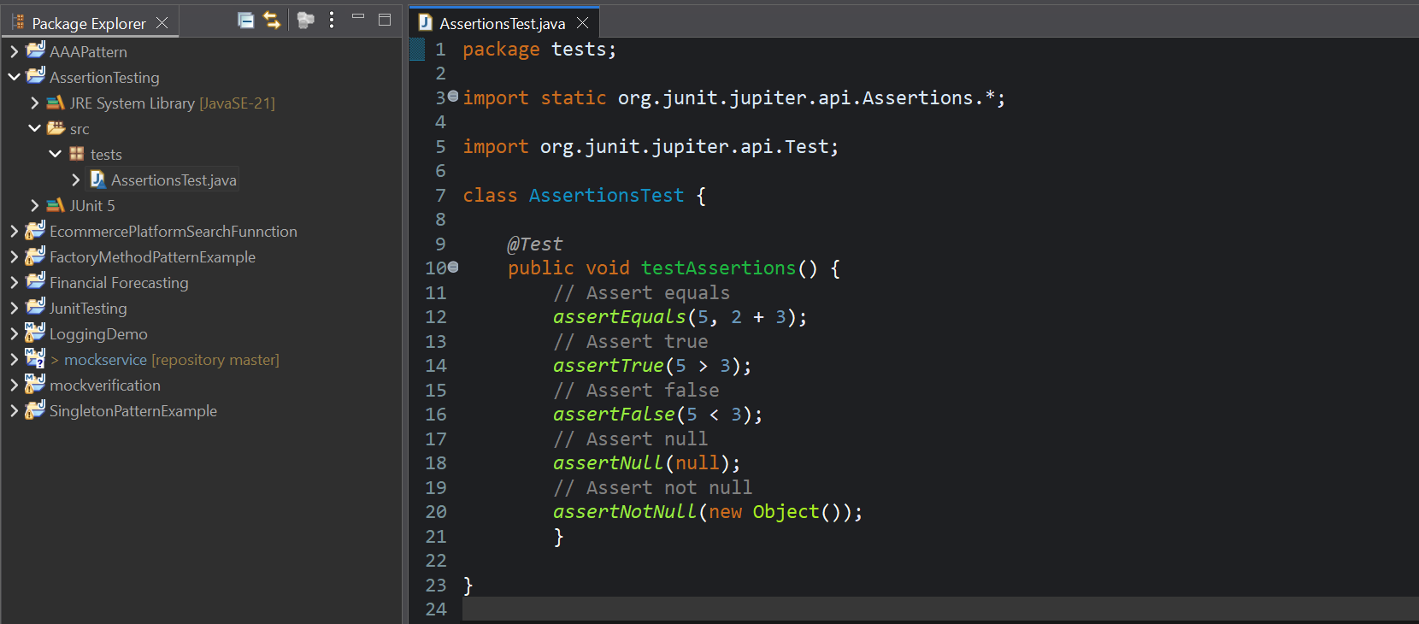

**Output:**

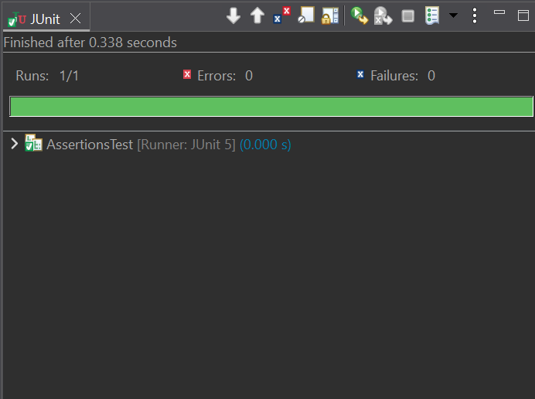

**Exercise 4: Arrange-Act-Assert (AAA) Pattern, Test Fixtures, Setup and Teardown Methods in Junit**

**Code:**

BankAccount.java

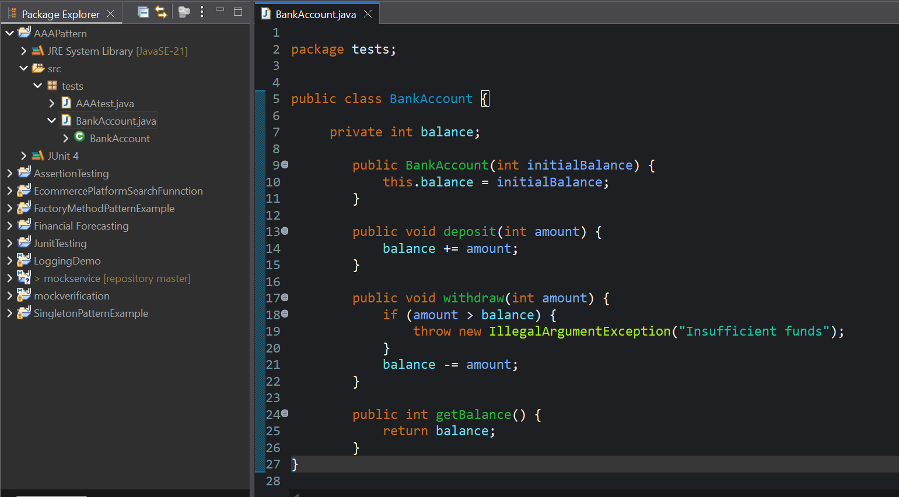

AAAtest.java

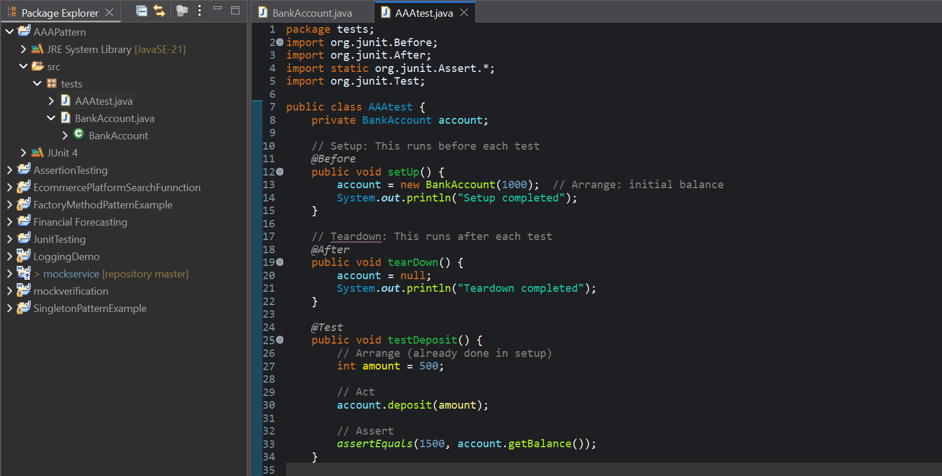

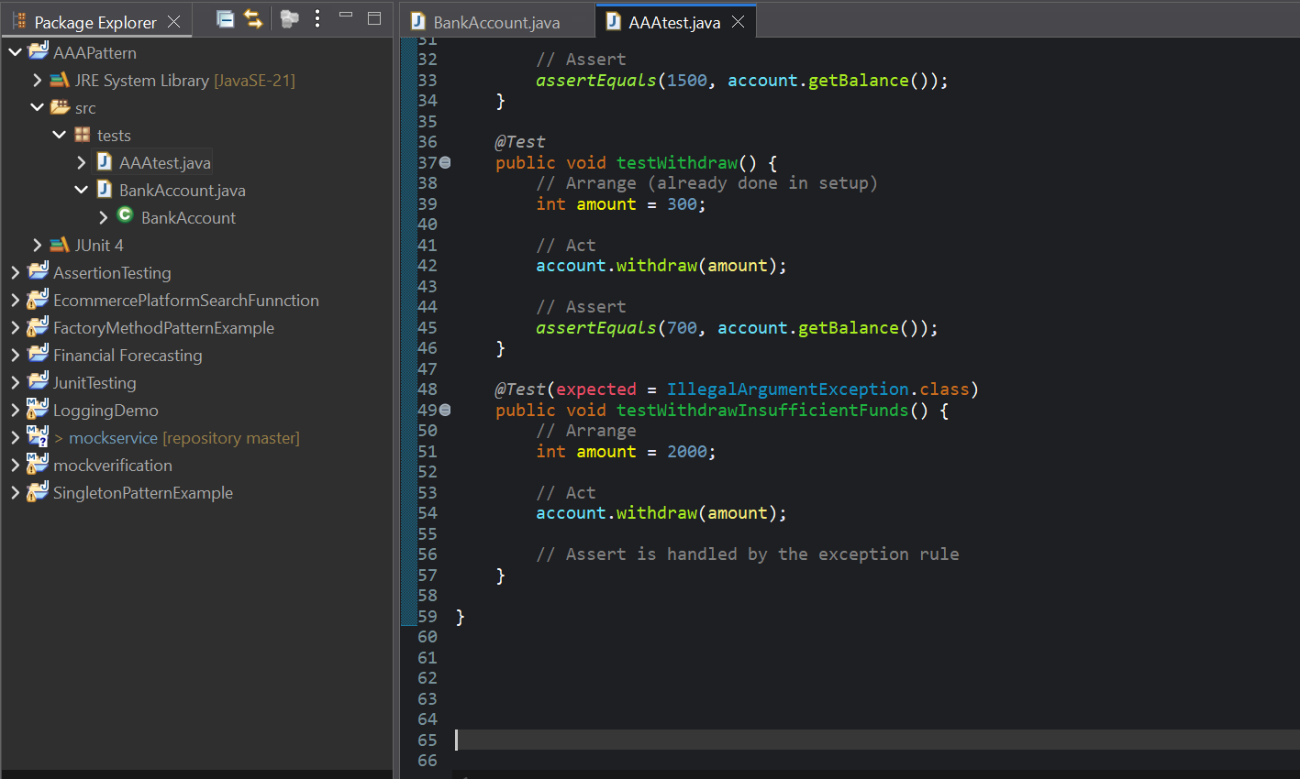

**Output:**

